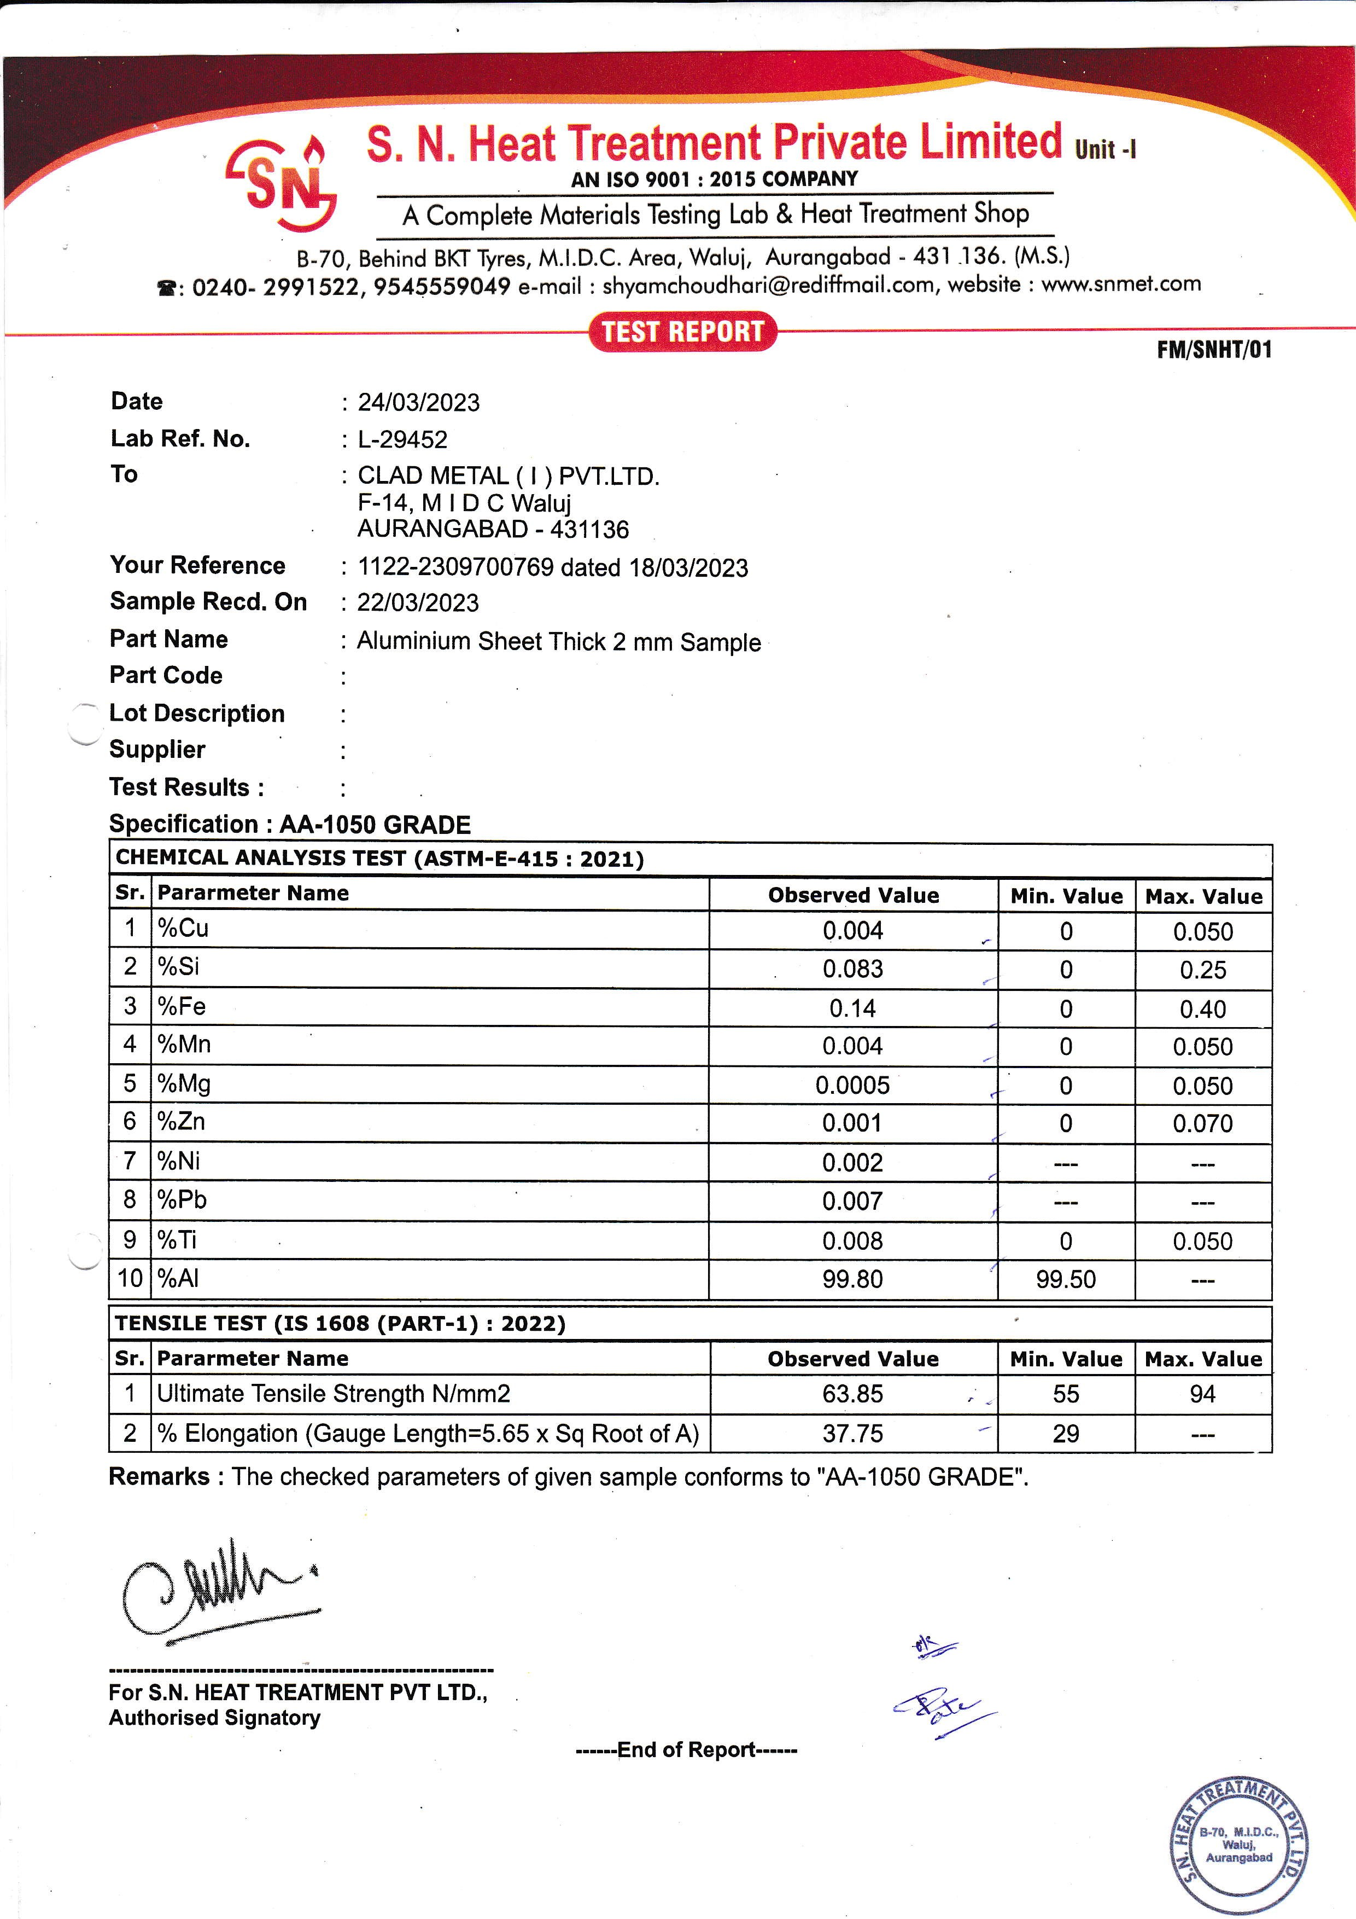



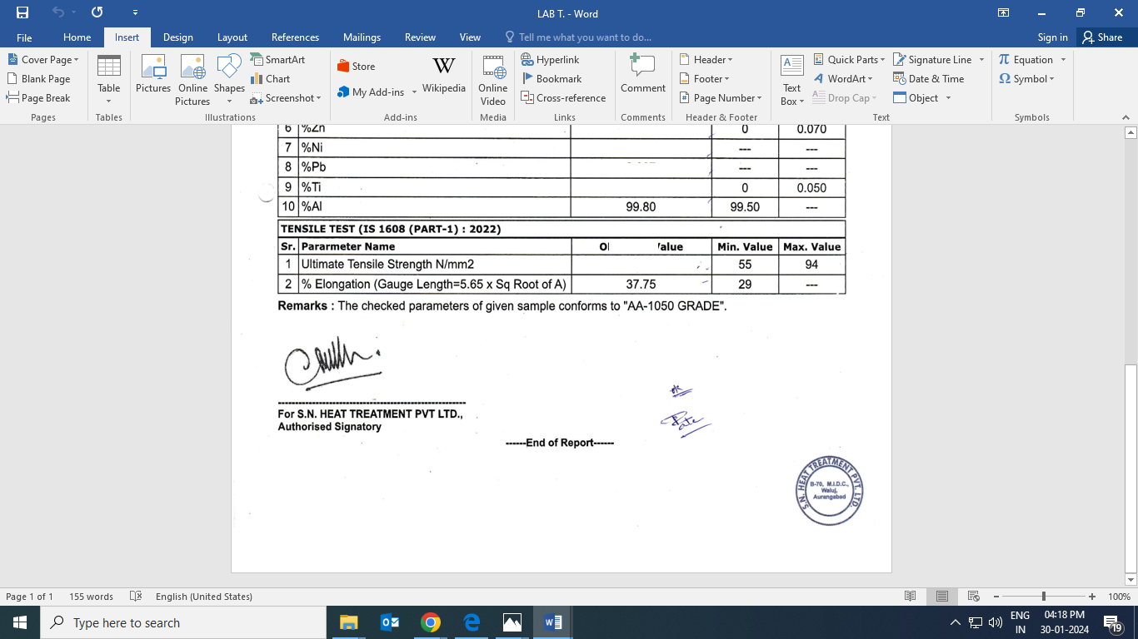

|  |  |  |  |  |
| --- | --- | --- | --- | --- |
| **Date :** 14/07/2023 | | | | |
| **Lab Ref.No :** L-17678 | | | | |
| **To :** CLAD METAL ( I ) PVT .LTD | | | | |
| F-14 M I D C Waluj | | | | |
| AURANGABAD - 431136 | | | | |
| **Your Reference :** 0454 dated 10/07/23 | | | | |
| **Sample Recd.On :** 10/07/2023 | | | | |
| **Part Name :** CU Tube 6.35 x 0.9 mm | | | | |
| **Part Code :** | | | | |
| **Lot Description :** | | | | |
| **Supplier :** | | | | |
| **Test Results :** | | | | |
| **Specification : COPPER ALLOY GRADE AS PER ASTM B-68** | |  |  |  |
| **CHEMICAL ANALYSIS TEST (ASTM-E-1086:2022)** | | | | |
| **Sr.** | **Parameter Name** | **Observed Value** | **Min.Value** | **Max.Value** |
| 1 | % Sn | 0.0005 | -- | -- |
| 2 | %Pb | 0.001 | -- | -- |
| 3 | %Fe | 0.003 | -- | -- |
| 4 | %P | 0.023 | 0.015 | 0.040 |
| 5 | %Mn | 0.0005 | -- | -- |
| 6 | %Zn | 0.030 | -- | -- |
| 7 | %Cu | 99.94 | 99.90 | -- |
|  |  |  |  |  |
| **TENSILE TEST (IS 1608 (PART-1) : 2022 )** | | | | |
| **Sr.** | **Parameter Name** | **Observed Value** | **Min.Value** | **Max.Value** |
| 1 | Ultimate Tensile Strength N/mm2 | 250.92 | 206.85 | -- |
| 2 | %Elongation (Gauge Length = 50 mm) | 47.88 | 40.00 | -- |
| **Remarks :** The Checked parameters of given sample conforms to’ ’Copper All Grade as per  ASTM- B-68’’ | | | |  |